Dam - Rosparquier Make believe at Esangee | 2 girls  2 boys  Fully marked | 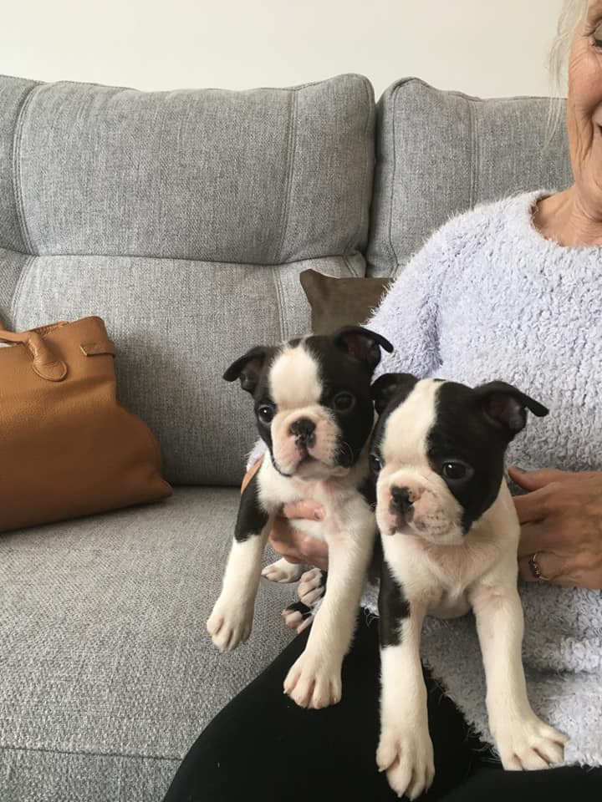
Sire - Beaconfell Big Brother | Will leave fully vaccinated  KC registered  Show potential  Born 29/07/19 | 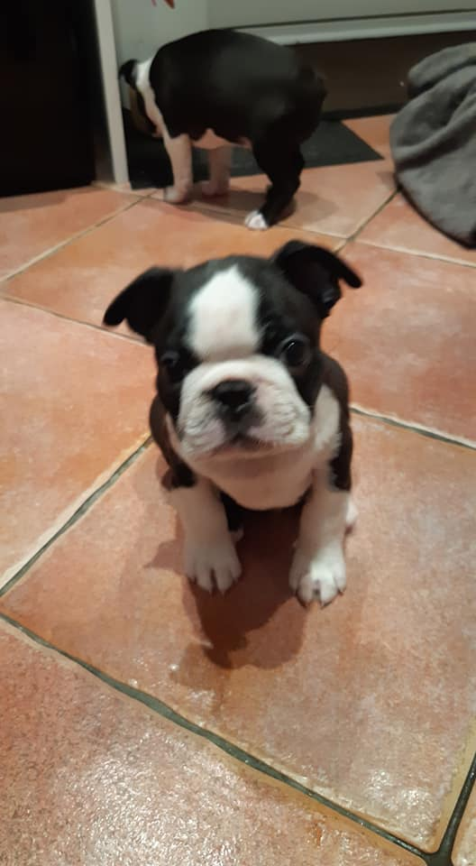
Contact - Sheila grace
01617637471

Dam – Llaremeth Venom N’ Vanilla  Grand mother – CH Eairycor Celtic Princess | 2 Girls  1 Boy | 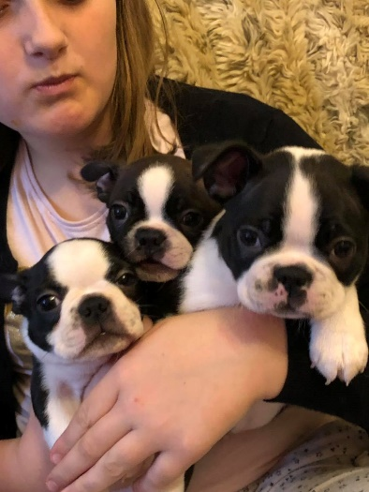
Sire Ch Eairycor celtic manxspirit  Grand sire – CH Llaremeth Pheonix Rising  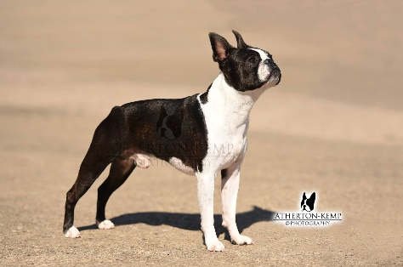 | First inoculations  Microchipped  KC registered  Puppy pack for new owners  Show potential  Born 8/8/19 | 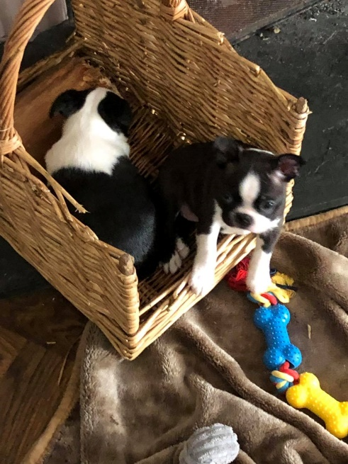
Contact Dawn Rathmell- 07831292602

DAM- Champaca Blossom for Geeseco  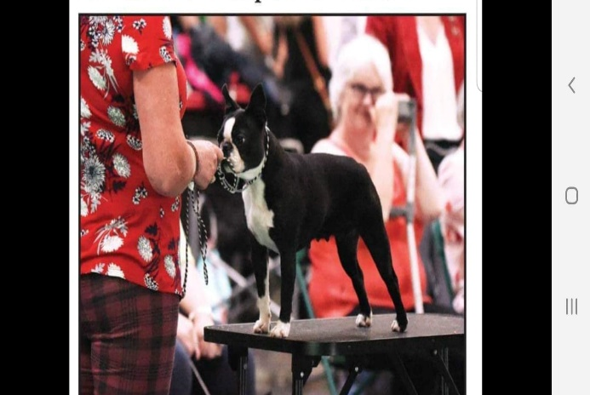 | 8 ½ Months. | 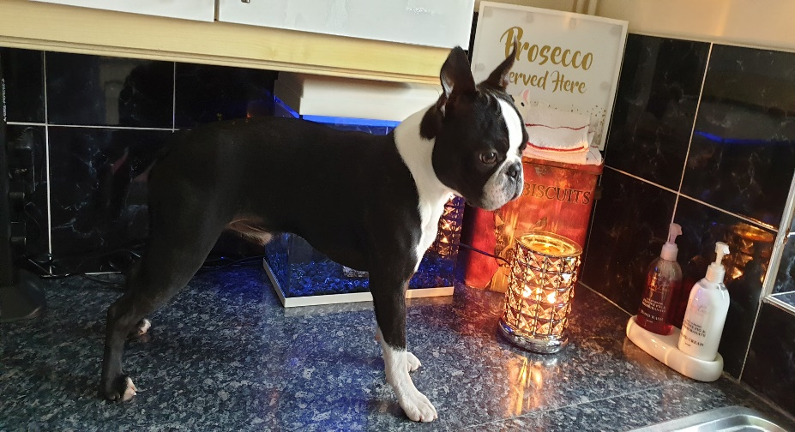
SIRE | Fully inoculated  Microchipped  KC registered  Puppy pack for new owner  Show potential  Born 8/8/19
Bron Ward – frenbosen@yahoo.com

