Available Puppies of members of the Northern Boston Terrier Club of England.
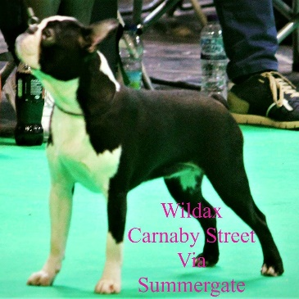  Dam  Wildax Carnaby Street Via Summergate | 3 Bitches available  DOB – 23/02/19 | 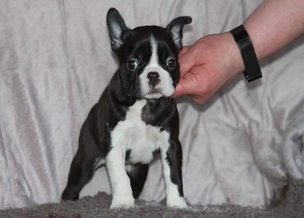
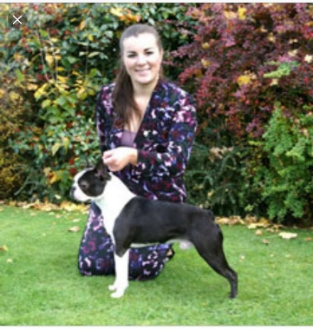  Sire  CH Wildax Augustus Brown | Black white & Brindle  HCF Clear | 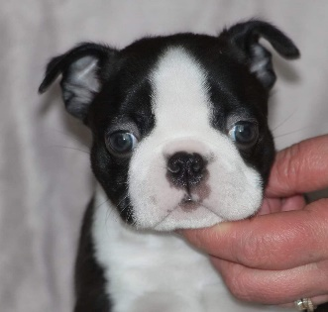
Helen Gracie  Email- Helen163@hotmail.co.uk | KC Registered  5 weeks insurance  Wormed & Microchipped  Puppy pack and paperwork. | 