Dam  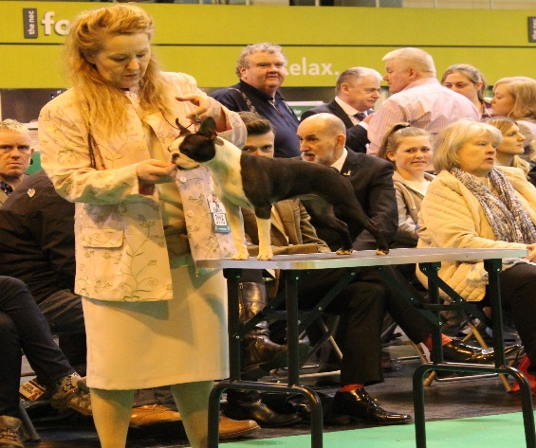  Vickvally just loving you | 2 dogs  2 bitches  07/19 | 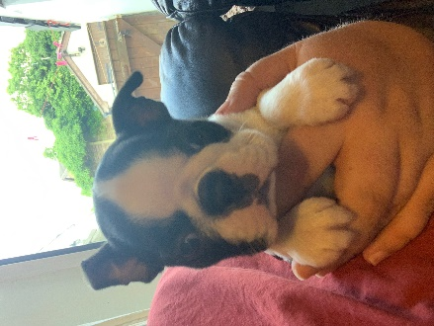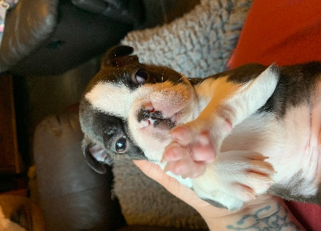
Sire  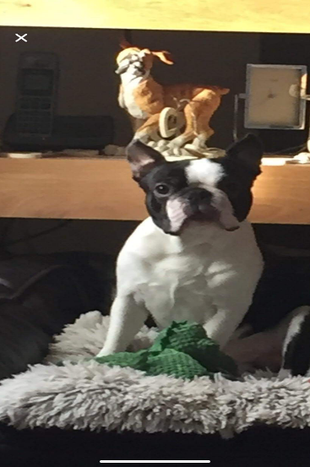  Vickvallys Golden torch | Black white & Brindle  HCF clear | 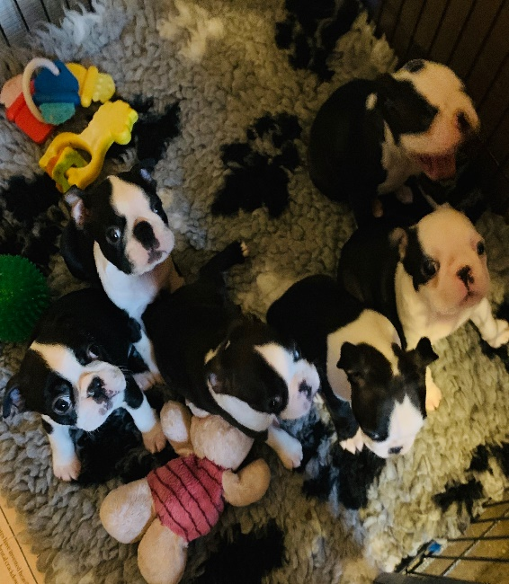
Vicky Schfaild  victoriaschfaild@yahoo.co.uk | KC Registered  5 weeks insurance  Wormed & Microchipped  Puppy pack and paperwork

Dam Eastonite stella sparkes | 1 dog  1 bitch  02/04/2019 | 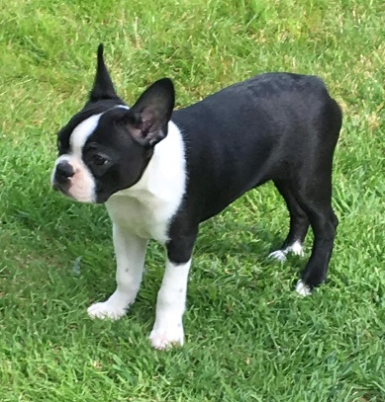
Sire CH Frenbosen Liverpool Lulaby | Black & White  HCF clear | 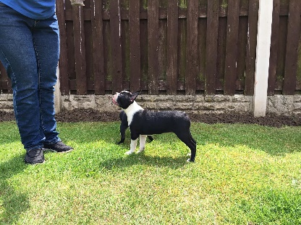
Joanne Parkes  Email- jmlamb1975@googlemail.com | KC Registered  5 weeks insurance  Wormed & Microchipped  Puppy pack and paperwork
Dam – Maranns keep it in style | Bitches  29/03/19 | 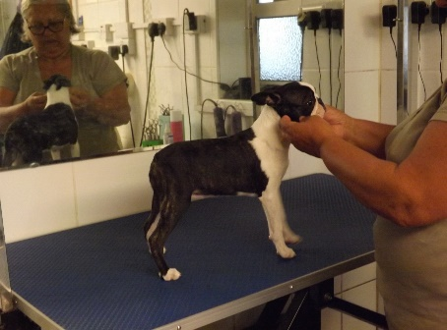
Sire – Maranns Roxy | Seal brindle & White  HCF
Martyn Saunders  marannpoodles@gmail.com | KC Registered  5 weeks insurance  Wormed & Microchipped  Puppy pack and paperwork

